# 5/8/18 Designer Core Certification Preparation – Joe Miller

1. Why certification?
   1. Offerings
      1. Core
      2. Advanced
      3. Expert
      4. Community.alteryx.com/certification
   2. Seat for June class.
      1. Register now.
      2. Queue up.
      3. All of June to complete the exam.
      4. 3 attempts to pass the exam (3 tries per month)
      5. Register in June to take in July
   3. When pass, certified for life
2. Concepts covered
   1. 20 most used tools in the Alteryx designer in addition to understanding basic UI/operational elements. Alteryx Designer Core exam is the most basic of the certification offerings
   2. Tools

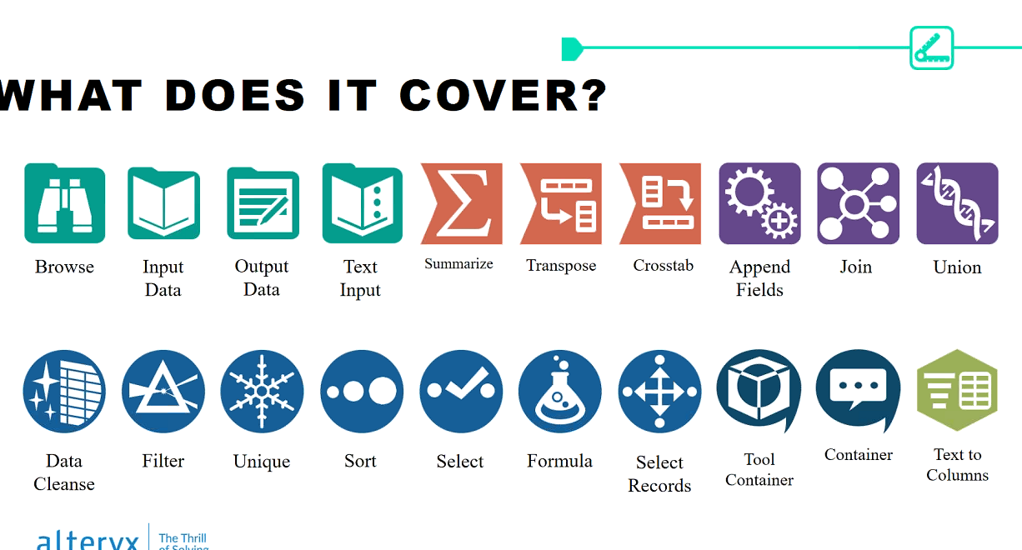

* 1. Types of questions

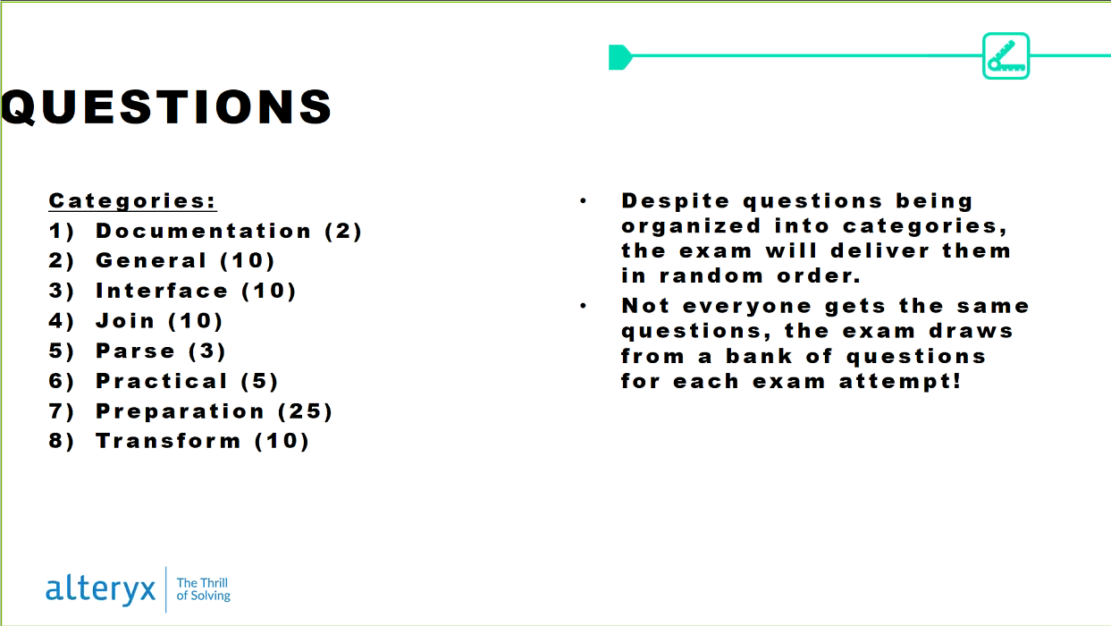

* 1. Container tool is mislabeled – comment tool
  2. Get ready for some minutiae. Be ready to deep dive into the tools, their functionality and behaviors
  3. Open Book
     1. Learning tool and assessment tool
     2. Exam designed to prompt people to research, trial and search Community
     3. If you spend the whole exam researching each question, you will run out of time
     4. Probably have time to research half of the questions on the exam
  4. End result
     1. Better Alteryxer
     2. 99% of people walk away with new-found knowledge from the exams

1. Format
   1. 2 hours
   2. 80 questions
   3. Pass threshold: 80%
   4. Question type: multiple choice
   5. Price: Free
   6. Mode: open book
      1. Open browser
      2. Open Designer
      3. Open documentation
   7. Finished in one sitting
2. Question Types
   1. Multiple choice
   2. True / false
   3. Multiple selection
   4. Matching
3. Categories
   1. Topics
      1. Documentation (2)
      2. General (10)
      3. Interface (10)
      4. Join (10)
      5. Parse (3)
      6. Practical (5)
      7. Preparation (25)
      8. Transform (10)
   2. Questions in random order
   3. Exam draws from a bank of questions; everyone gets different exams
   4. Resources (Open book)
      1. Alteryx Community
         1. Alteryx academy (question on the end)
         2. Tool mastery (articles about the tool)
         3. Knowledge base articles
      2. Help documentation – F1
      3. One Tool Samples
      4. Sample Workflows
      5. Try it in Designer
      6. 2018 is the latest version
   5. They do not distribute answers and whether or not one’s answers are correct
   6. Most every question has an answer somewhere
   7. Books: help documentation and community
4. Scoring
   1. M/C and T/F is worth 1 point
   2. Multiple selelction and matching 1 to 3 points
   3. 80% (total points scored / total points possible)
   4. Focus on the questions
   5. 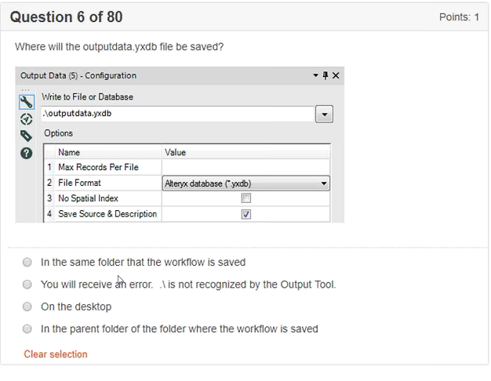
   6. 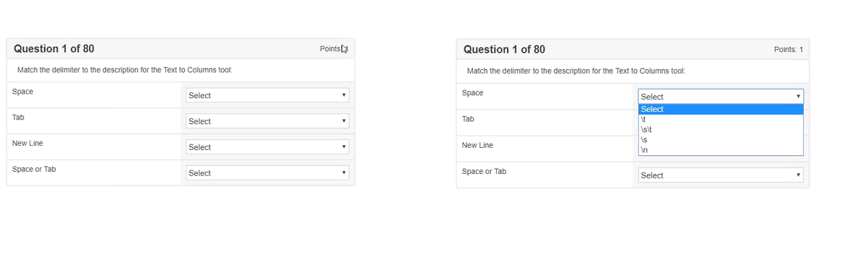
   7. 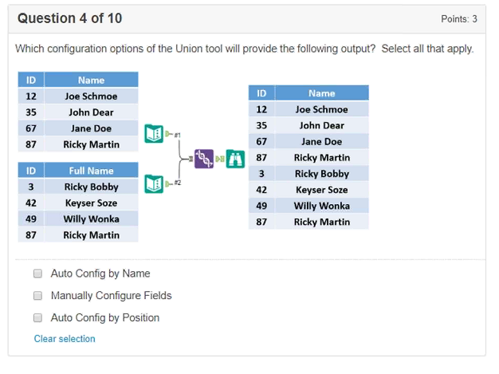
   8. 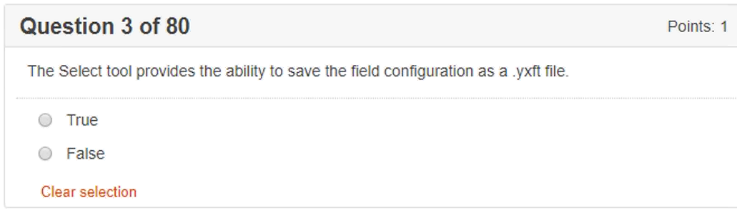
5. Exam Environment
   1. 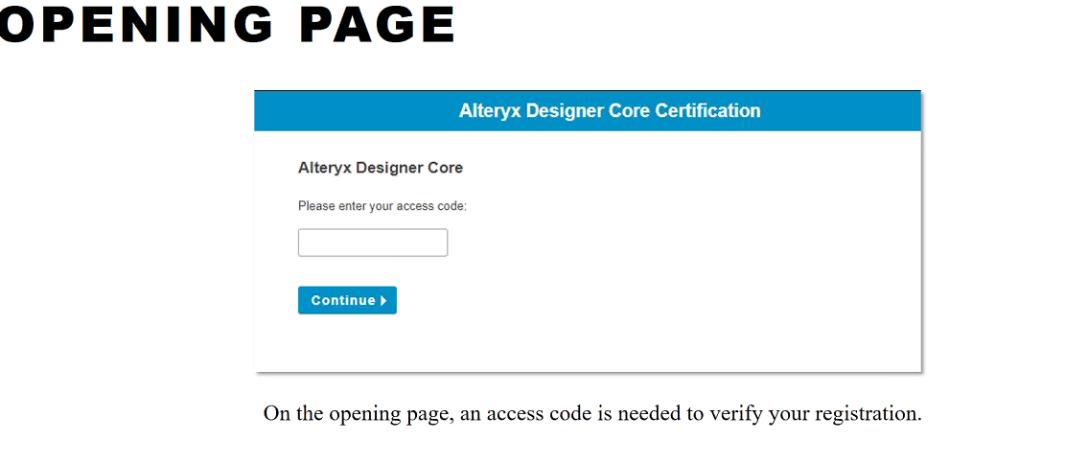
   2. 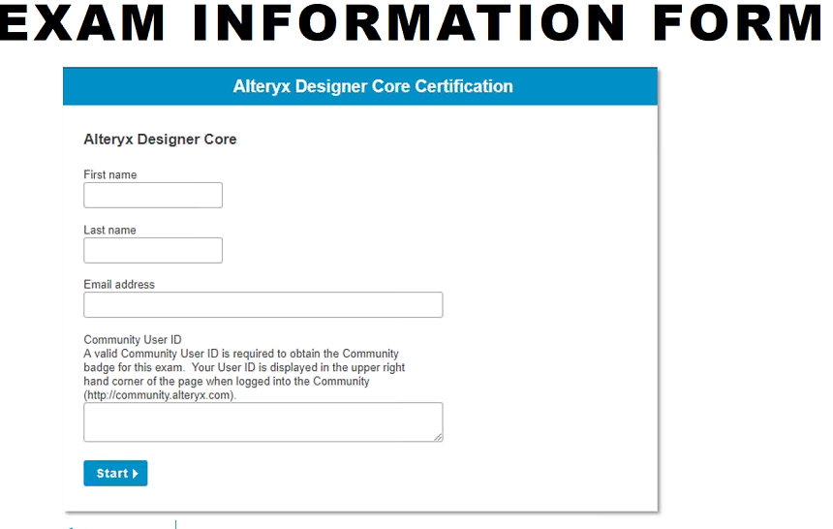
   3. 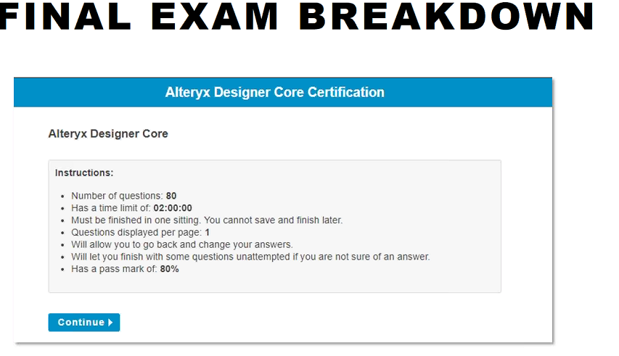
   4. 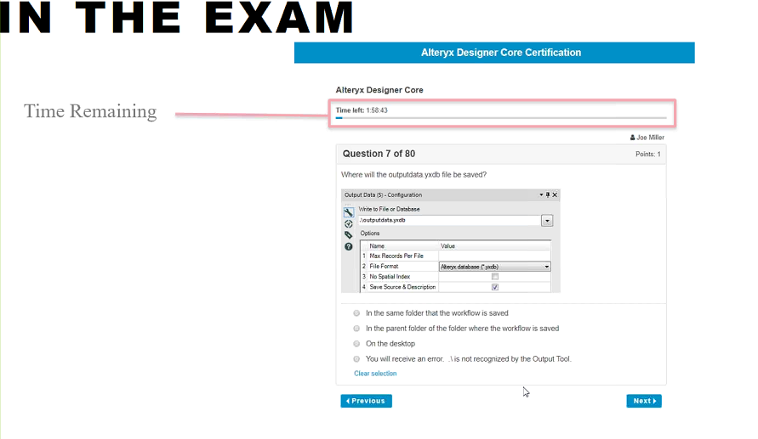
   5. Bring a notepad and a pen (to keep track of problems that may be revisited)
   6. 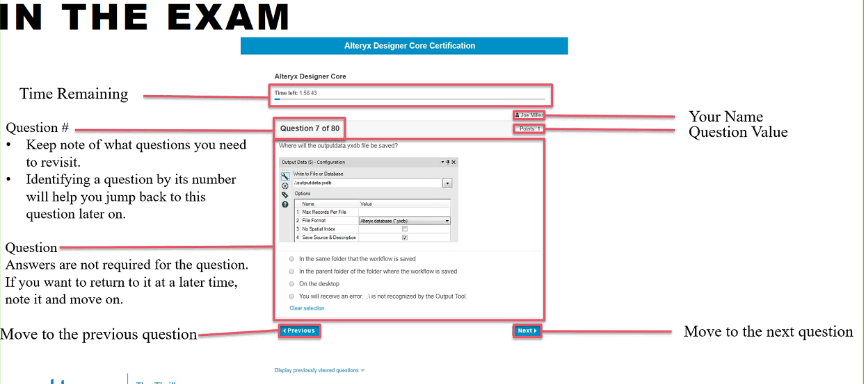
   7. 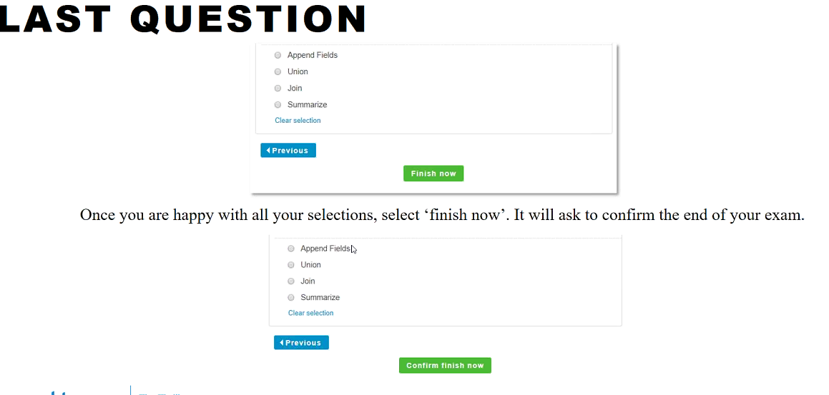
   8. 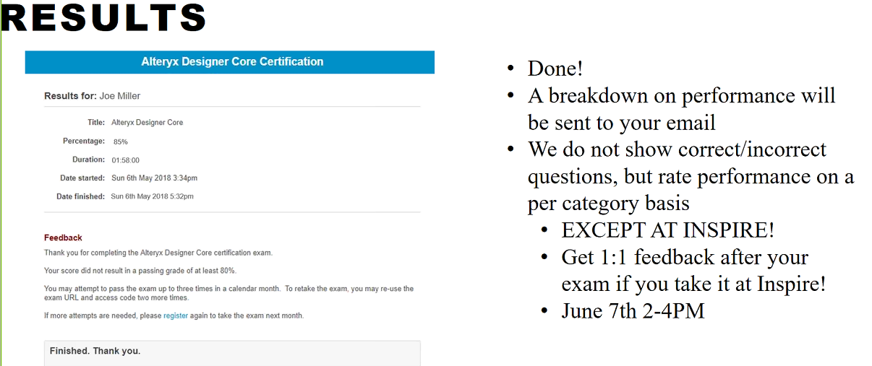
   9. If you pass, you will receive your certificate within 10 minutes
   10. At Inspire, they will go through your questions with you (Alteryx Event)
   11. ~80% are 1 point questions (could vary by exam)
   12. 90 seconds per question
6. Exam Strategy
   1. 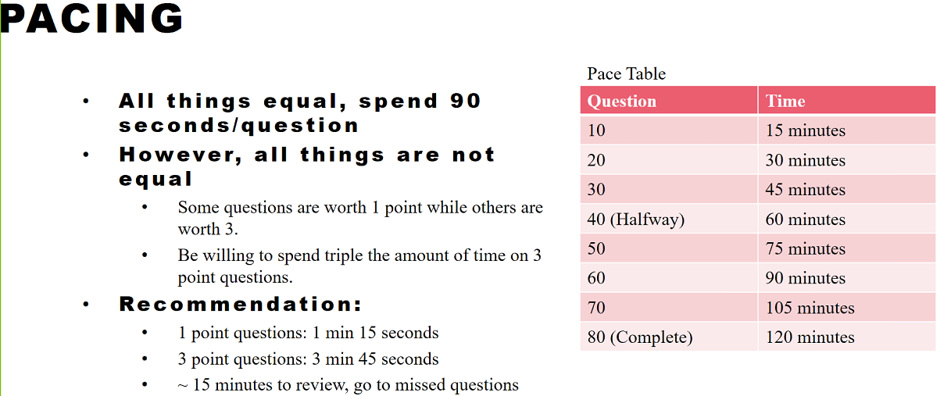

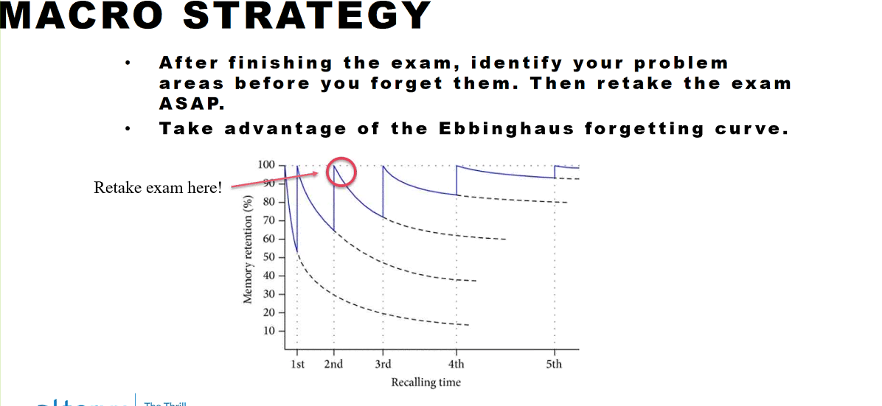

1. Preparation
   1. 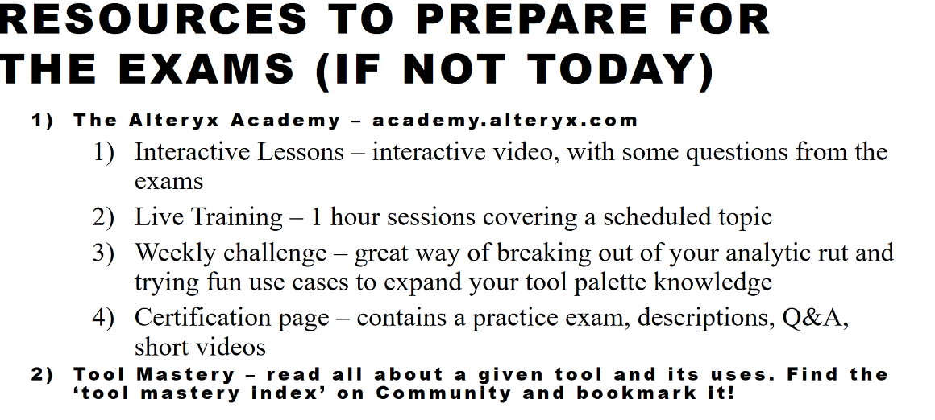
   2. 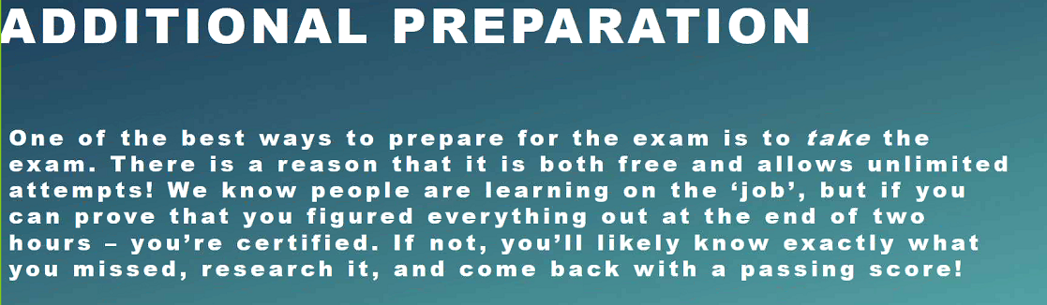
2. Recommends
   1. Live Trainings
   2. Weekly Challenges